Instructions for Taking Group Attendance
You will receive an email reminding you to take attendance of your group.
Click on Enter Attendance.

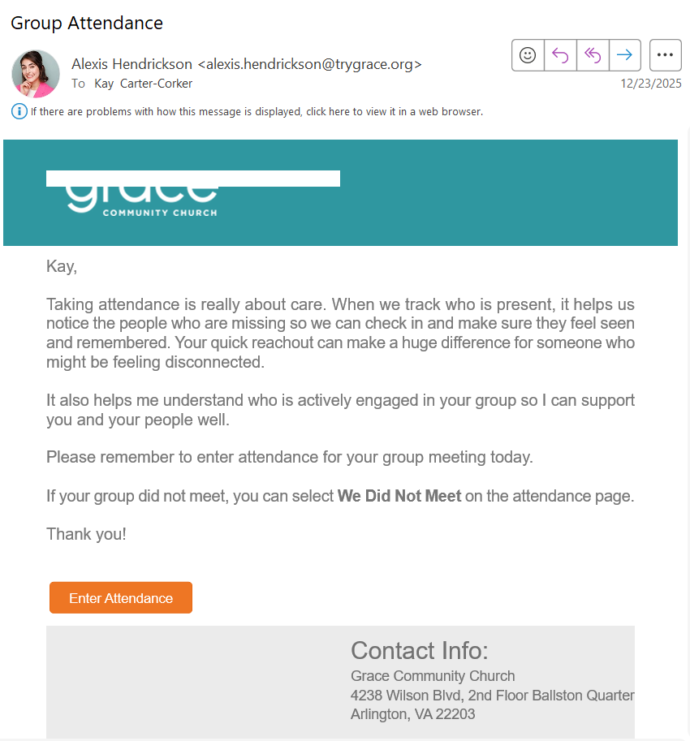

Click on the row to select the date of your meeting.

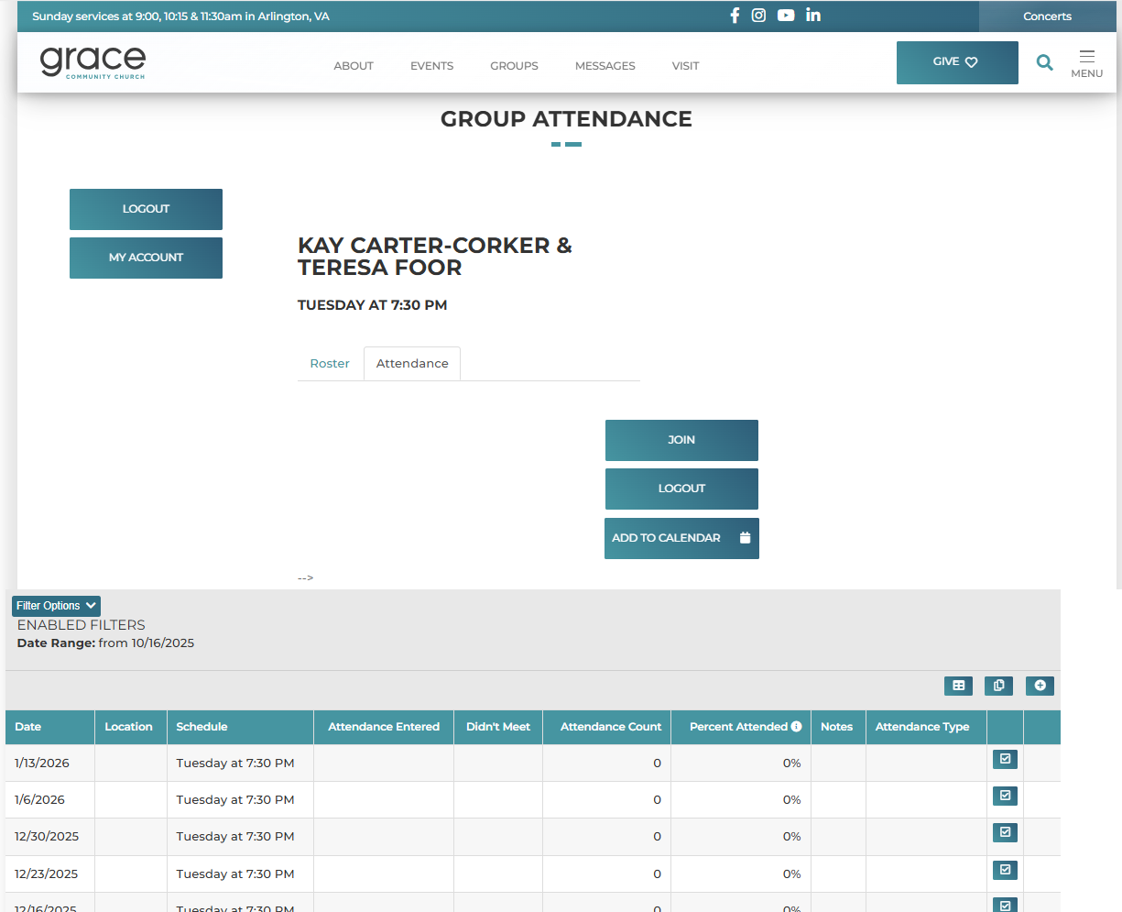

Click on the person’s tile to indicate that they attended the meeting on this date.
Click on “We Did Not Meet” if your group did not meet on this date.
Click on “Back” to save the changes. See that the attendance has been recorded.

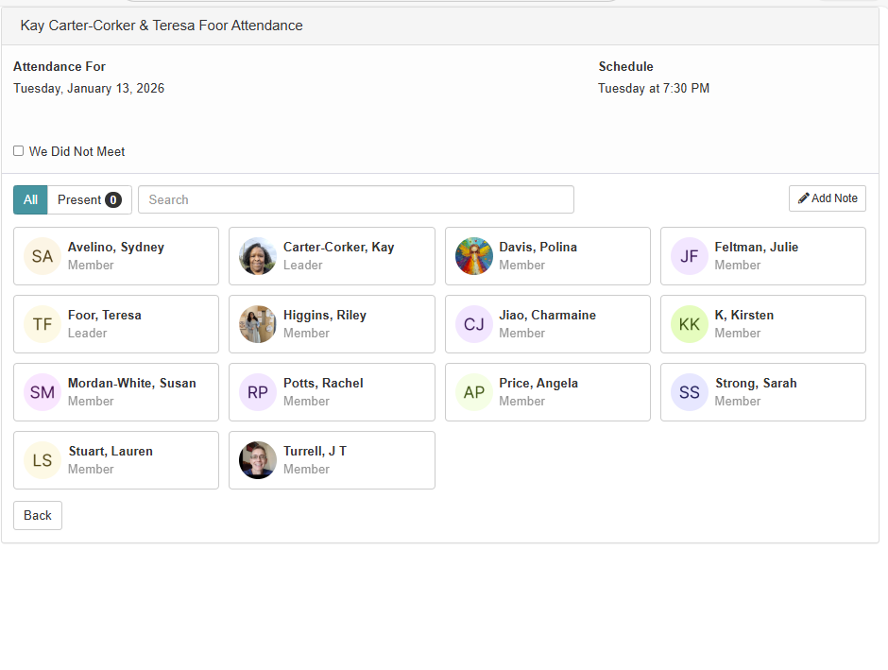
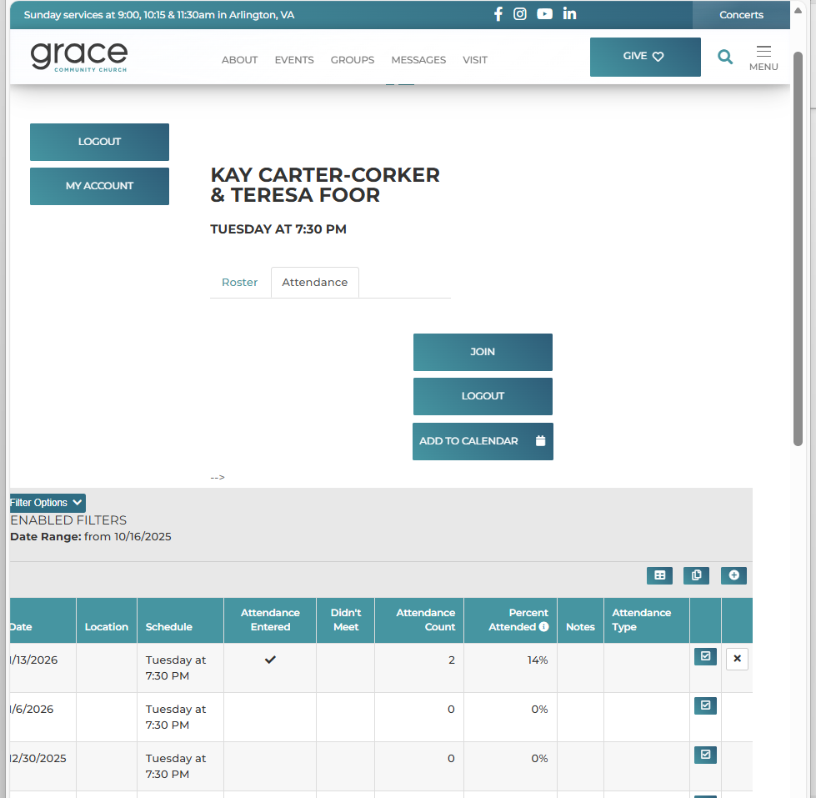

You can click on logout to leave your group toolbox.

